Below is Drive link To download the Softwares

https://drive.google.com/drive/folders/1X9UUtbYAfYfcXF1DT4Ffw_eCIzaBdkVh?usp=drive_link
when u click on this Link you will Get to download the Software
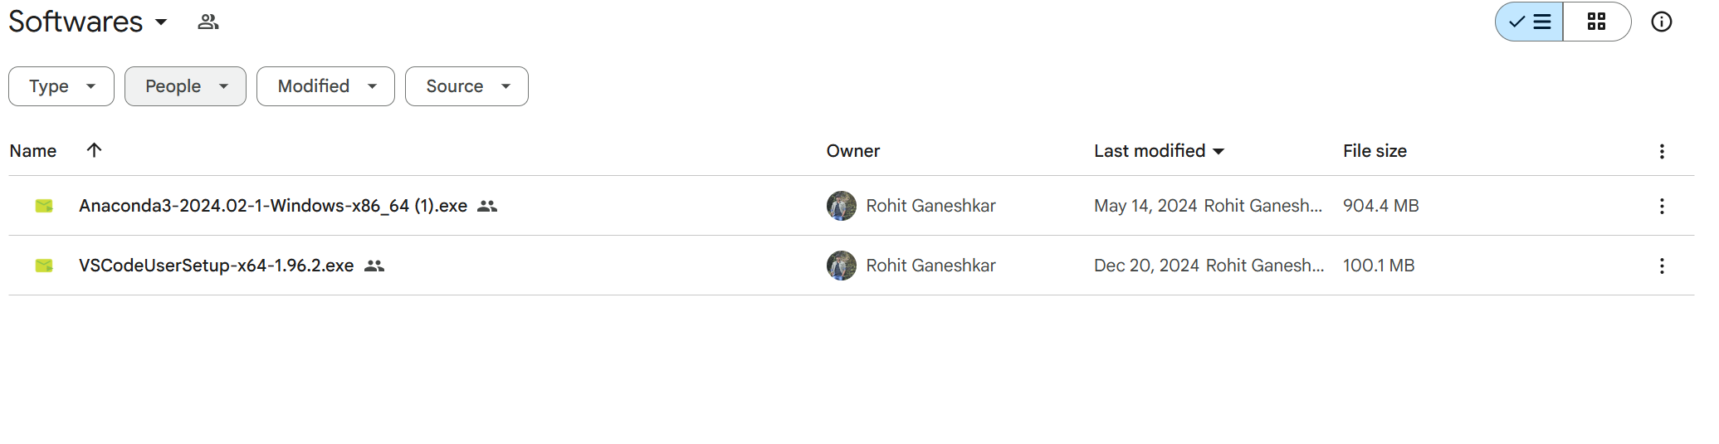
Download this Software

First Install Anaconda 3 in your System

Installation Steps:
Step 1 double click on that

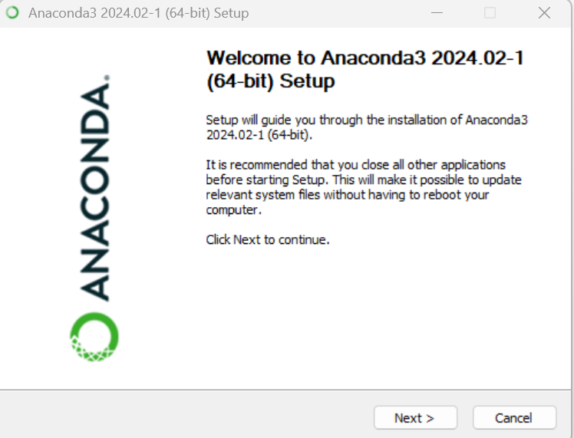

Step 2 Click on next

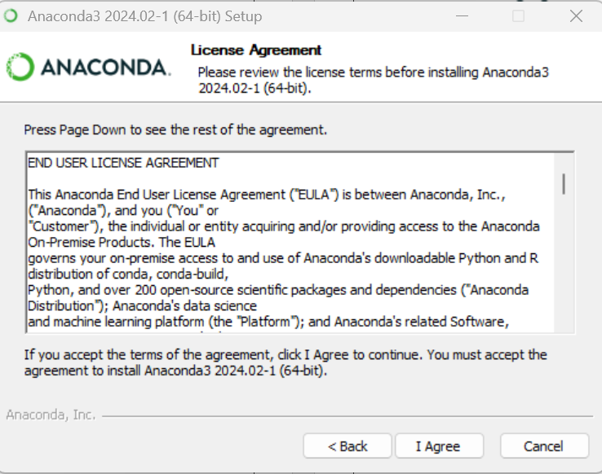

Click on I agree
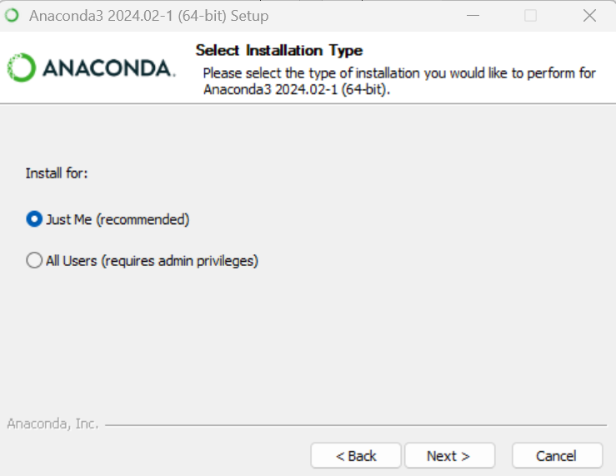

Then Next
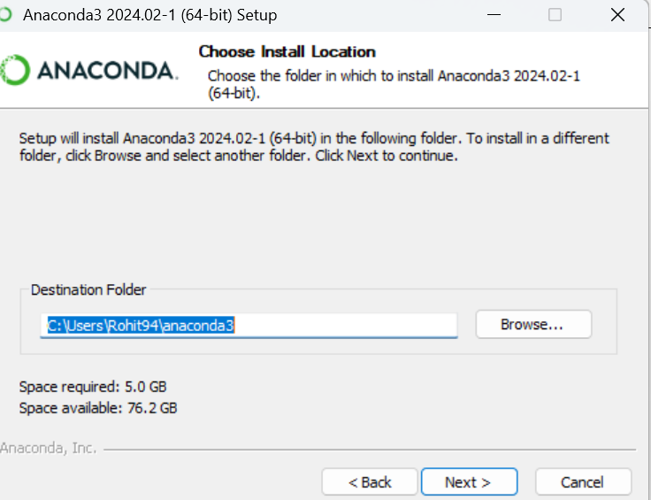

Click on next it will Install in your system
(depends on the System Configuration it will take time)

After Getting Installation Done:

Now in the windows Search button type Jupyter Notebook you will going to get below window in that click on the jupyter notbook

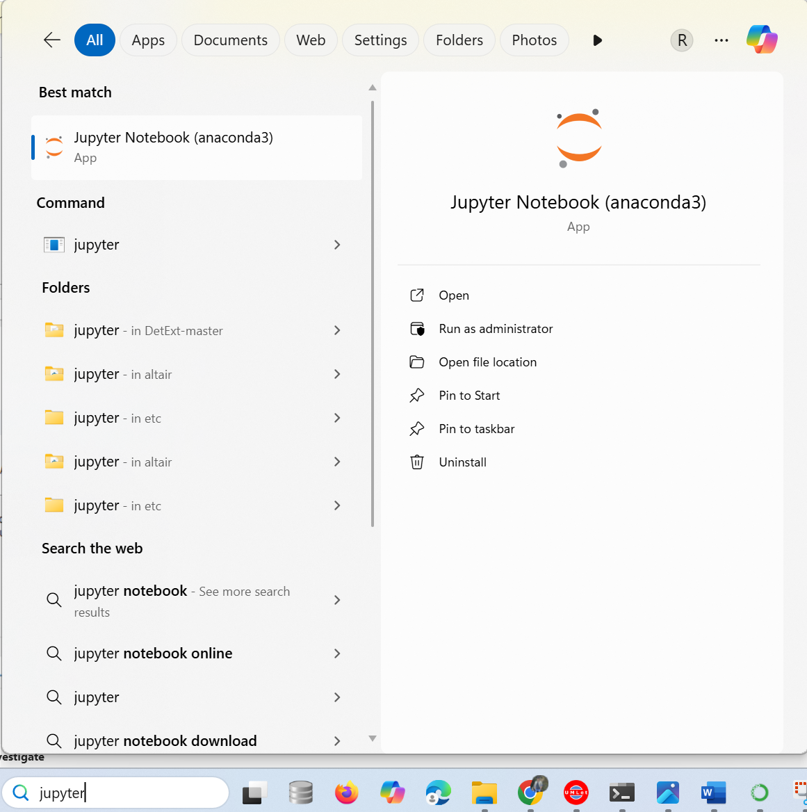

After click on that you will going to see Black jupyter server

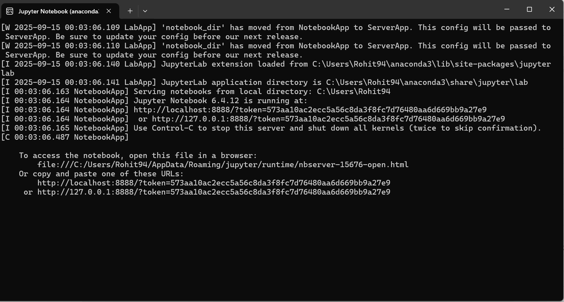

Now after this
1)it will directly open on your any browser or it will show you the browser selection
If in case it is not showing any browser the copy that
Url http://localhost..................................e9
And paste in any browser

Suppose if it is open in browser you will get lik

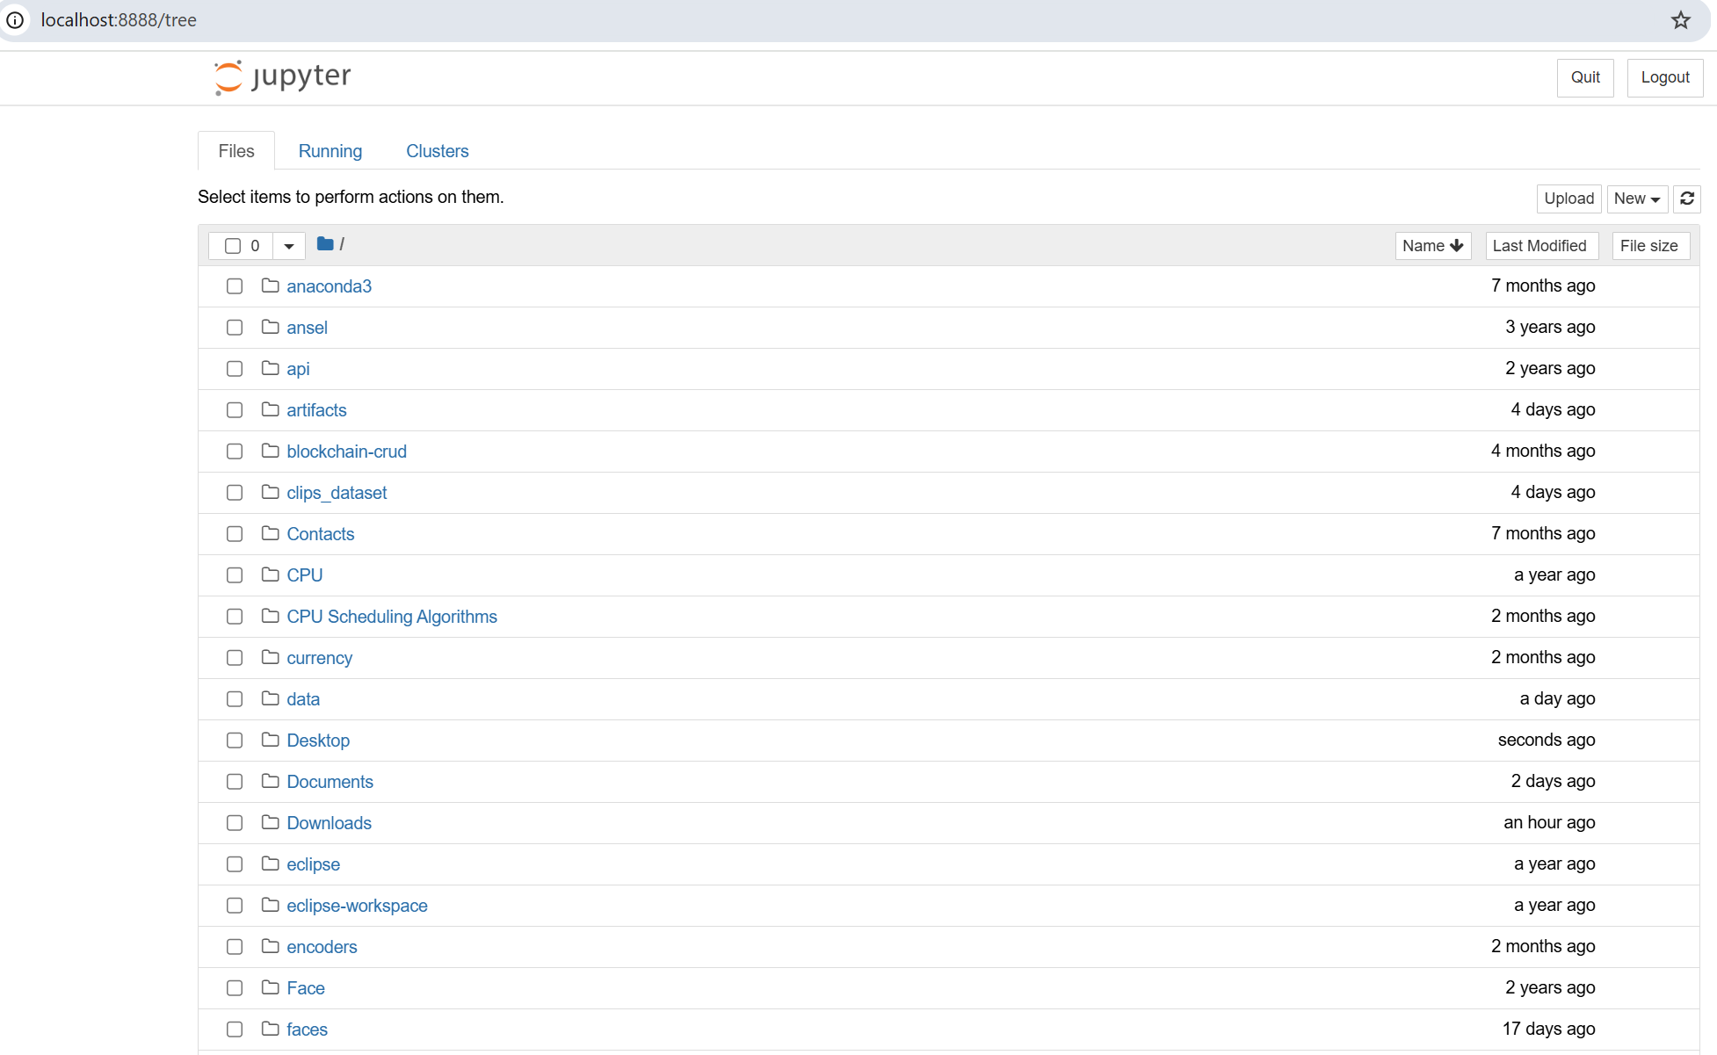

Now what u need to do is in the right sider there is one upload button click on that it will show u the file selection. Now in each file I have given and jupyter file that is nothing but
.Ipynb extension u select that file and click open this will load in tou your file.

If you go down it will show you the file and double click on that it will open with code part.

Tat code is for you that what you have done till now 8 weeks progress report.

(the given file consists of)
1)Jupyter file or python file(in few cases)
2)report till now what you have done
3)datasets for your project
4)Software Link

